17.121: For a spherical or cylindrical surface, the area 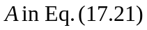is not constant, and the material must be considered to consist of shells with thickness 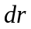and a temperature difference between the inside and outside of the shell 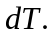 The heat current will be a constant, and must be found by integrating a differential equation. a)Equation (17.21) becomes
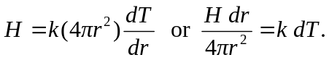
Integrating both sides between the appropriate limits,
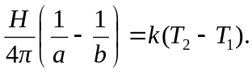
In this case the “appropriate limits” have been chosen so that if the inner temperature  is at the higher temperature , the heat flows outward; that is, 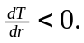 Solving for the heat current,
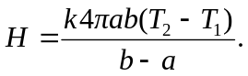
b) Of the many ways to find the temperature, the one presented here avoids some intermediate calculations and avoids (or rather sidesteps) the sign ambiguity mentioned above. From the model of heat conduction used, the rate of changed of temperature with radius is of the form 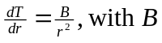a constant. Integrating from 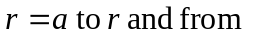 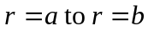gives
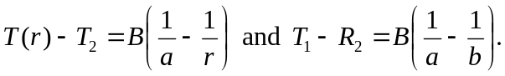
Using the second of these to eliminate B and solving T(r) (and rearranging to eliminate compound fractions) gives
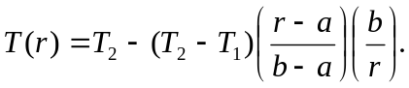
There are, of course, many equivalent forms. As a check, note that at 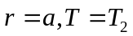 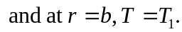 c) As in part (a), the expression for the heat current is
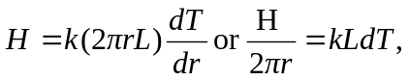
which integrates, with the same condition on the limits, to
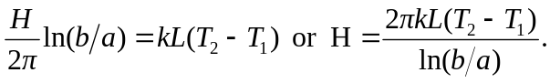
d) A method similar (but slightly simpler) than that use in part (b) gives
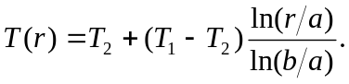
e) For the sphere: Let 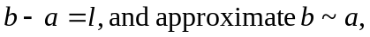 with a the common radius. Then the surface area of the sphere is 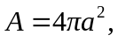 and the expression for H is that of Eq. (17.21) (with l instead of L, which has another use in this problem). For the cylinder: with the same notation, consider
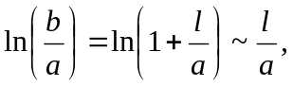

where the Taylor series approximation for 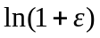 for small has been used. The expression for H then reduces to 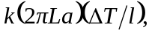 which is Eq. (17.21) with 